ECEN 454 - Lab Report

Lab Number: 1
Lab Title: Introduction to Cadence Schematic Design & Simulation
Section Number: 341
Student’s Name: Abhishek Bhattacharyya
Student’s UIN: 731002289
Date: 9/14/2024

TA: Nishank Bansal

Full Adder Schematic
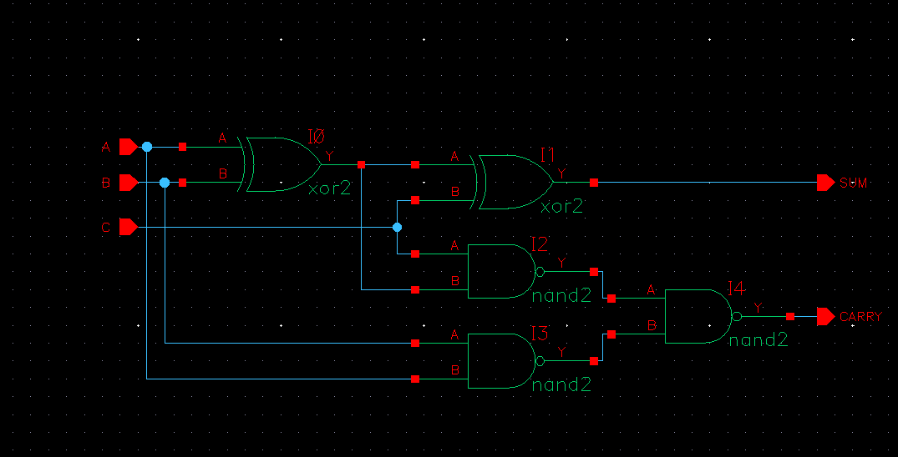

Full Adder Symbol
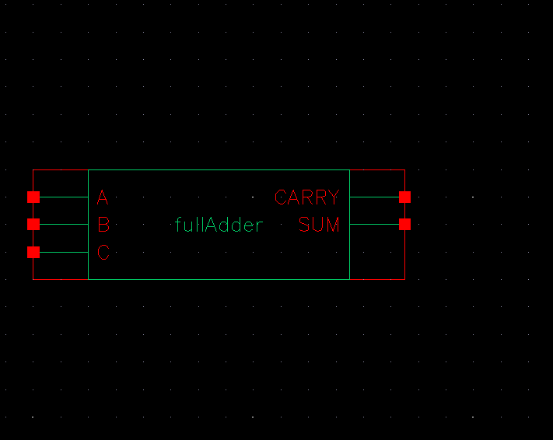

Full Adder Test Stimulus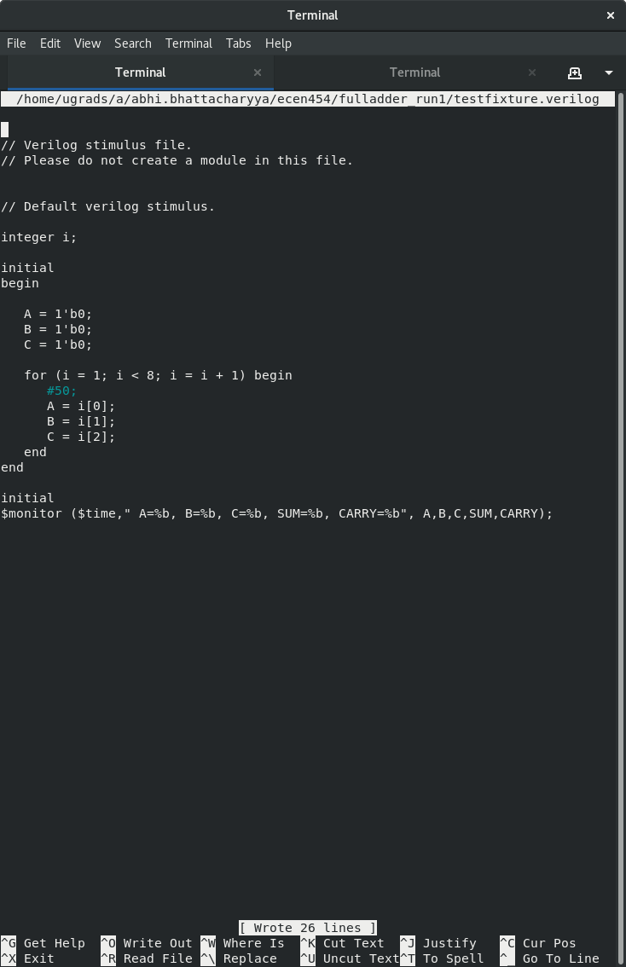

Full Adder Sim Results vs. Expected Results Truth Table

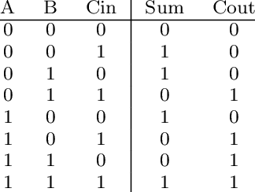
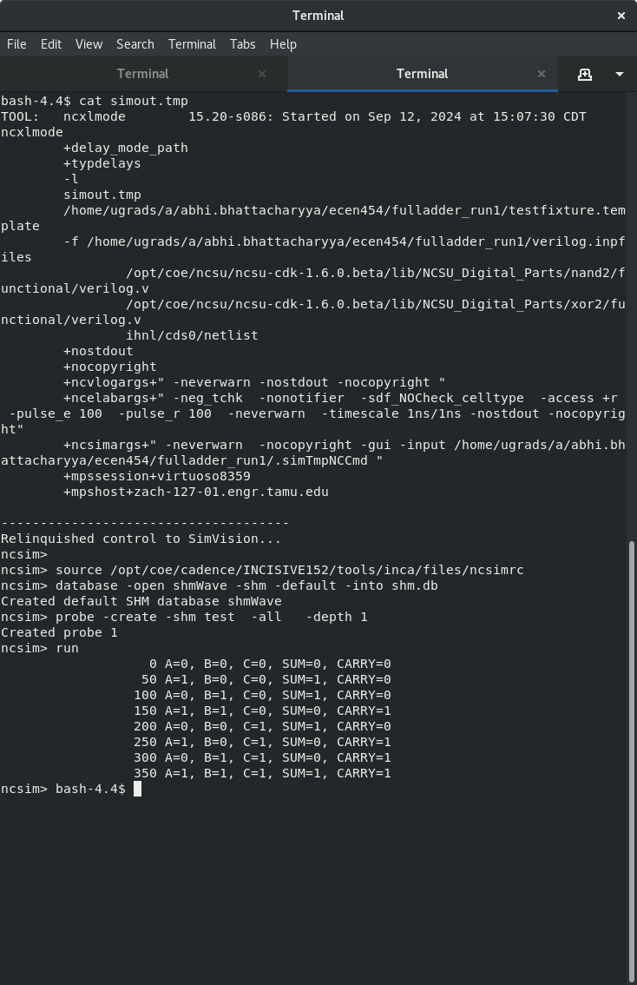
All available input combinations were tested above in the simulation for the full adder. All calculations match the given truth table, so this design passes all tests in the simulation.

4-Bit Adder Schematic
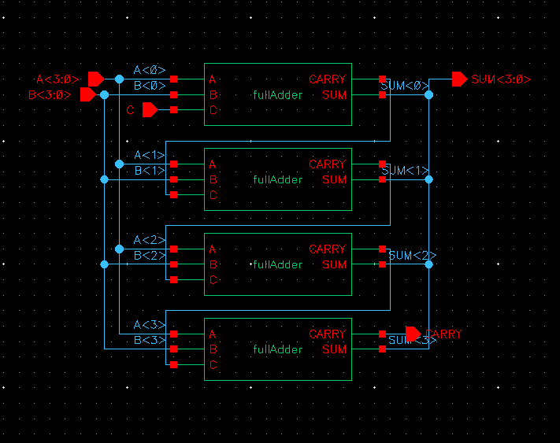

4-bit Adder Symbol
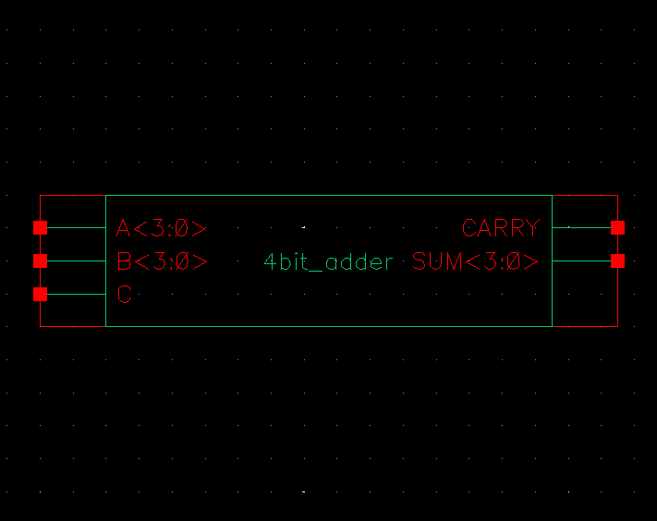

4-bit Adder Test Stimulus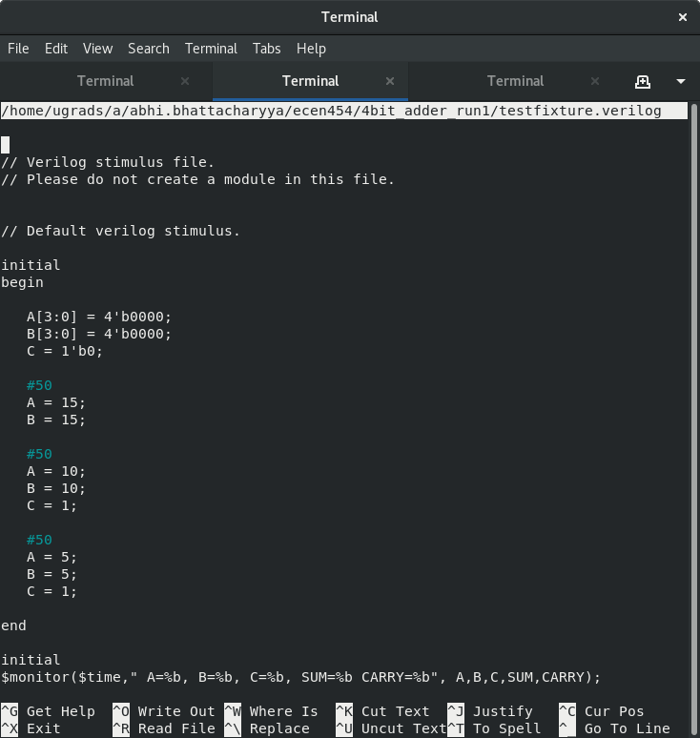

4-bit Adder Sim Results

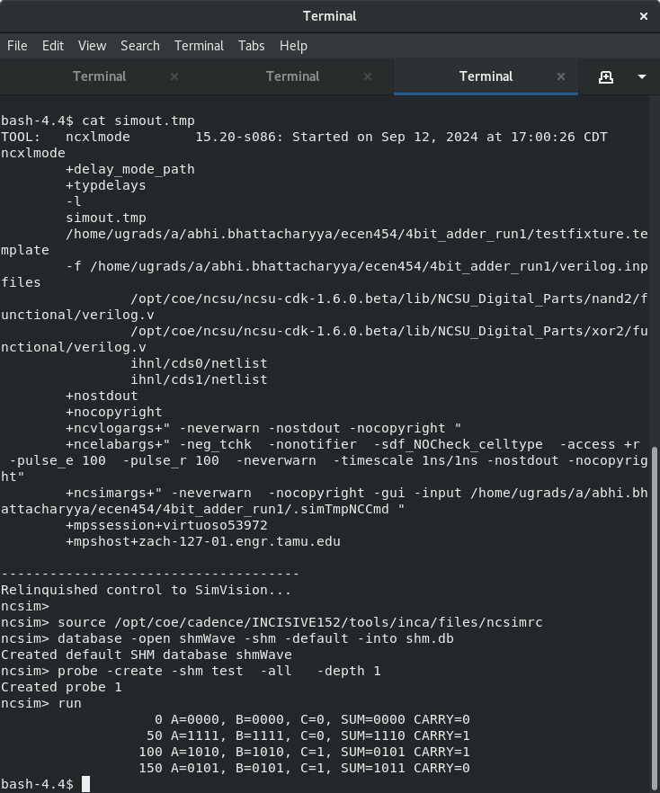
The three specified cases were simulated for the 4-bit adder. The expected results were:
- 1111 + 1111 + 0 = 0000 1
- 1010 + 1010 + 1 = 1110 1
- 0101 + 0101 + 1 = 1011 0
All test results from the simulation match the expected results for these given cases, so the module passes all tests.
4-Bit Register Schematic
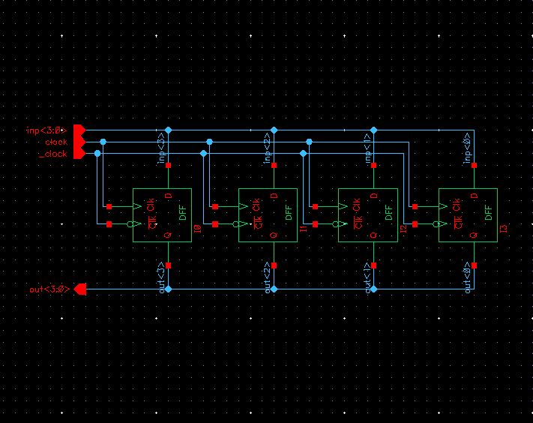
4-Bit Register Symbol
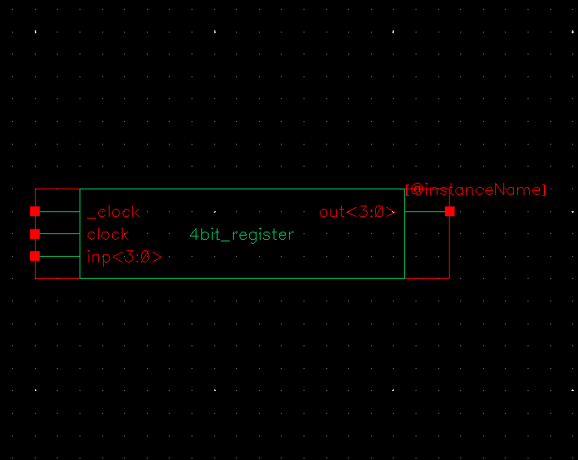

4-Bit Register Test Stimulus
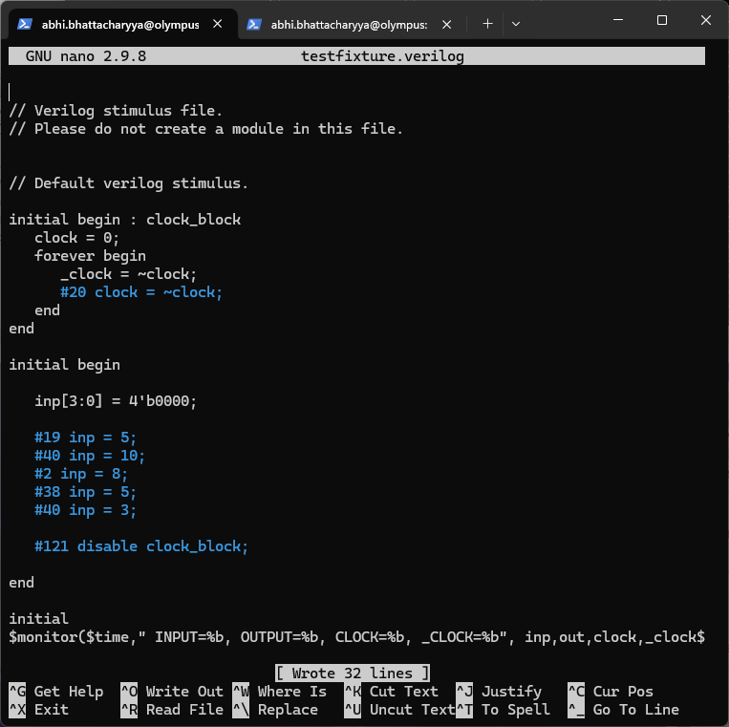

4-Bit Register Sim Results
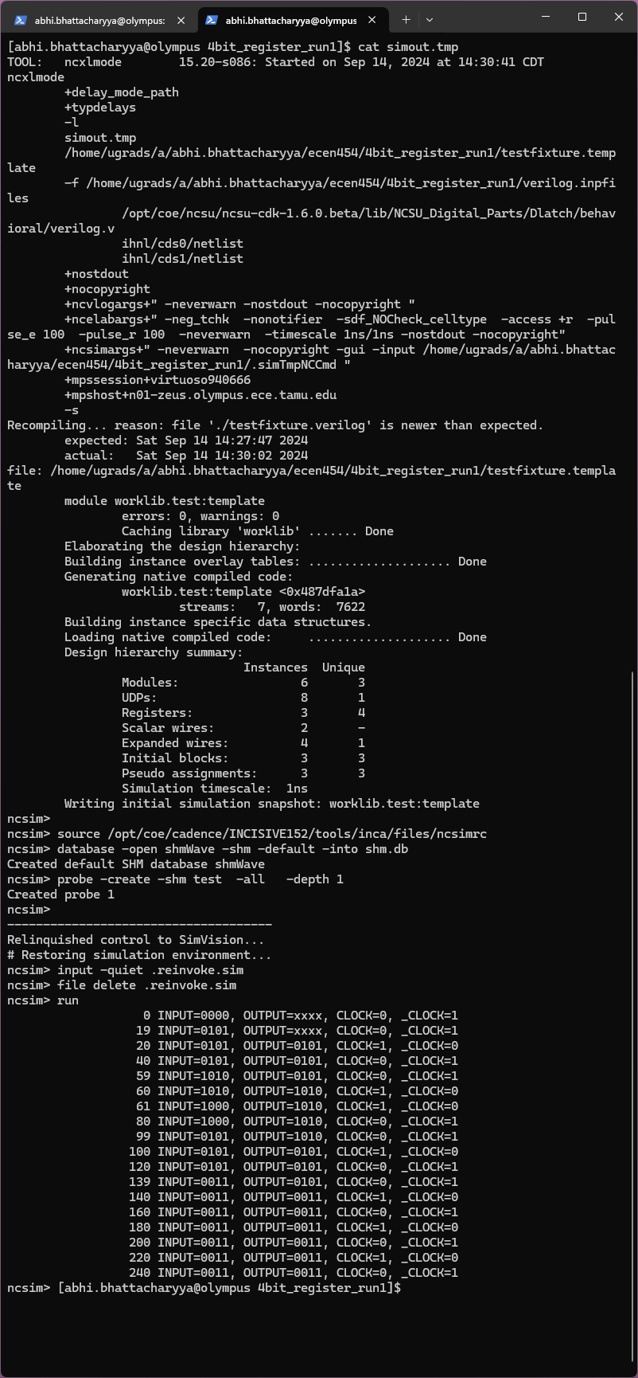
As shown in the test stimulus code, the register was simulated on a clock signal with a period of 40 time units. The first clock rising edge is at t = 20 time units. A race condition was observed when setting the input signal exactly on the rising edge (20 + 40n), where the register’s output would sometimes update with the input; and other times remain unchanged. This behavior was random and nondeterministic, pointing to a race condition. To avoid this, the input was changed one time unit before the register's clock cycle.
The cases tested for the 4-bit register were as follows.
Time Input Expected Output
0 0000 XXXX
19 0101
20 0101 0101
59 1010 0101
60 1010 1010
61 1000 1010 (Changing input in the middle of a clock cycle to test for issues)
99 0101 1010
100 0101 0101
139 0011 0101
140 0011 0011
The simulation results matched the expected results, so the register design worked correctly.
8-Bit Pipelined Adder Schematic & Symbol
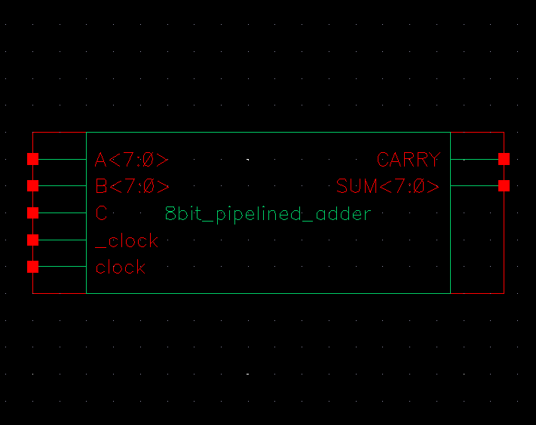
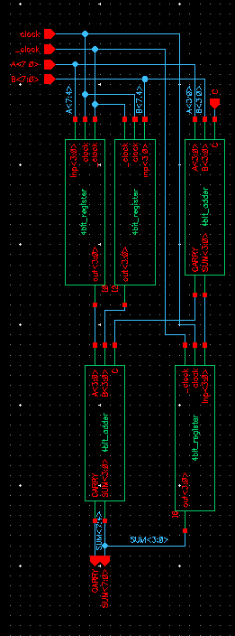

8-Bit Pipelined Adder Test Stimulus

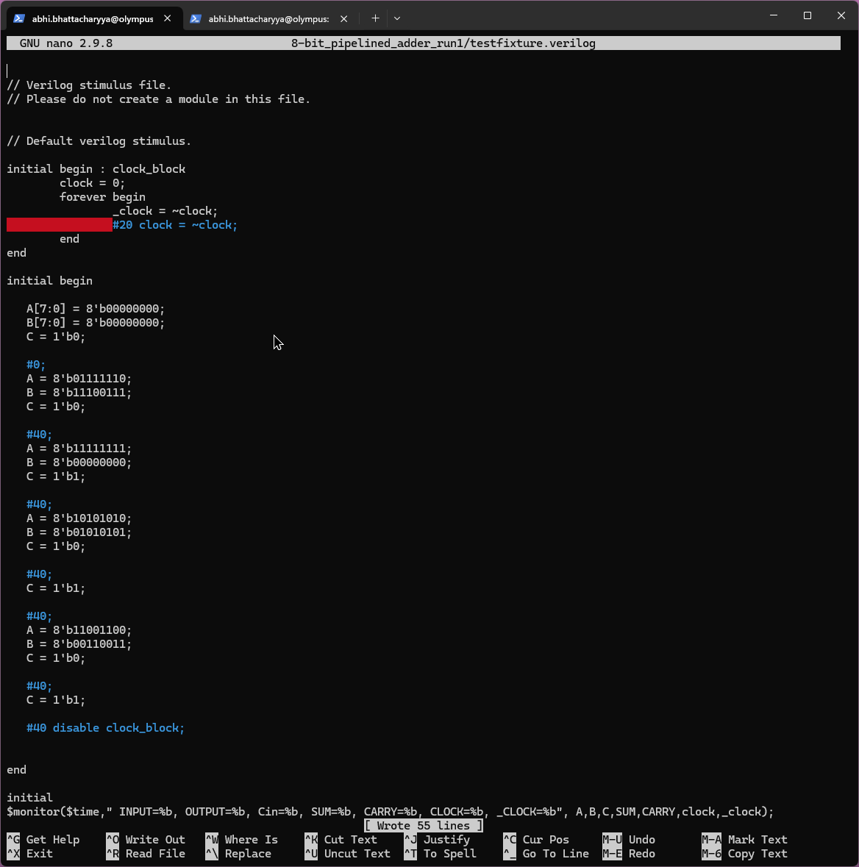

8-Bit Pipelined Adder Sim Results
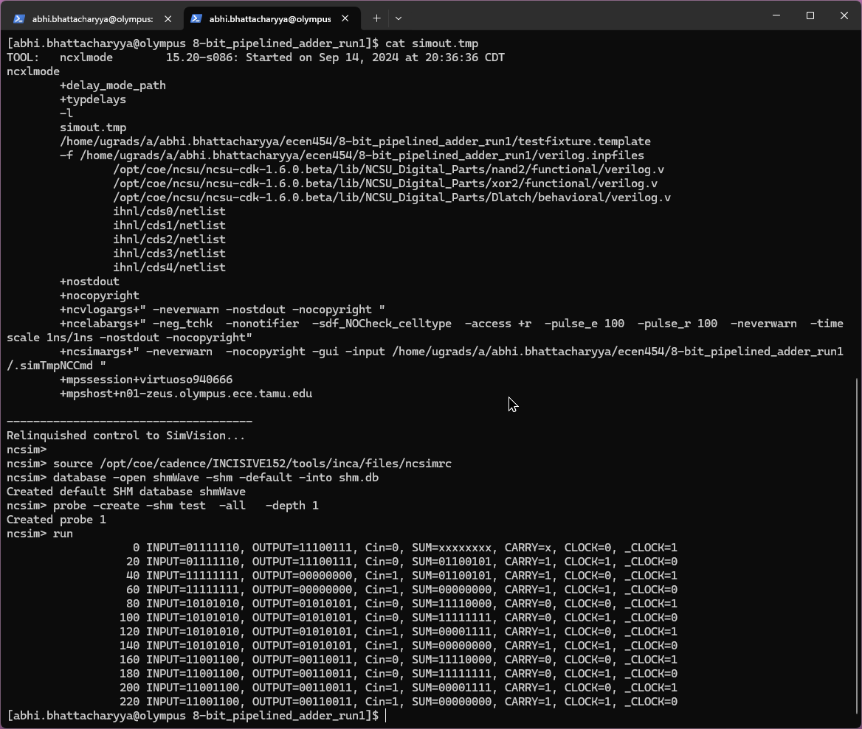
As shown in the test stimulus code, the register was simulated on a clock signal with a period of 40 time units. The first clock rising edge is at t = 20 time units.
The six specified cases were simulated for the 4-bit adder. The expected results were:
Time | A | B | C | SUM | CARRY
20 | 1111110 | 11100111 | 0 | 01100101 | 1
60 | 11111111 | 0 | 1 | 00000000 | 1
100 | 10101010 | 1010101 | 0 | 11111111 | 0
140 | 10101010 | 1010101 | 1 | 00000000 | 1
180 | 11001100 | 00110011 | 0 | 11111111 | 0
220 | 11001100 | 00110011 | 1 | 00000000 | 1
Time units were added above to match the clock period (40) and initialization time (t = 20) used for simulation. The simulation results and calculations match the expected results. One thing of note is that the upper 4 bits of the sum update on the first clock cycle’s falling edge, and the lower 4 bits update on the next clock cycle’s rising edge. This is due to the layout of registers in the pipelined adder, as the design was optimized to use fewer registers. Since the output of this adder should only be read during each rising clock cycle, and the output results are correctly computed by the time of each rising clock cycle, this design satisfies the specifications for Lab 1.

